Activity 1. Algorithm of Prim

I implemented two Prim algorithms. First I implemented a n^3 algorithm and then I optimized it to make it n^2. In each algorithm I have commented the step by step in the .py file to understand it more easily. I measured the times of the n^2 one.

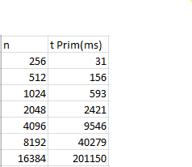

After making calculations with the formula t2 = (n2/n1)^2 \* t1 we can assure that the times obtained in the table concur with the times expected